Suresh Shrestha
6/19/2026
Module-3.2 Assignment

1. full code
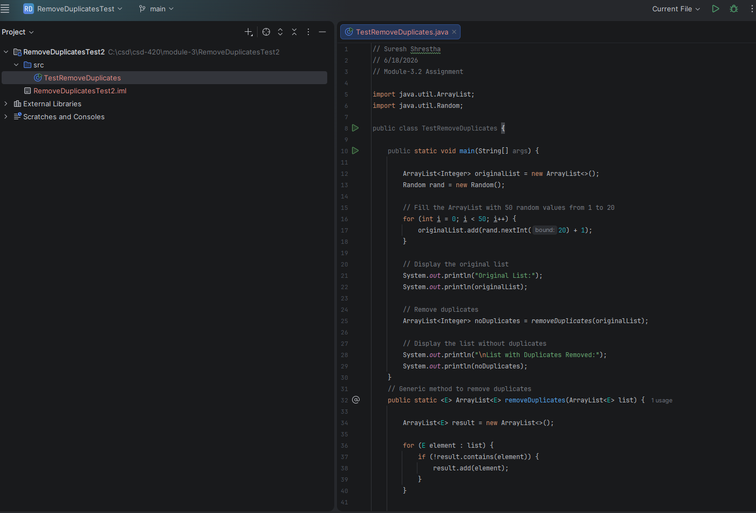

2. Program output after running
